How to use BGI script

Matlab scripts:

BGIsingle.m (runs BGI on a single image)

BGIbatch.m (runs BGI on all images in a folder)

BGIcallable.m (is called by the above two scripts to execute the analysis)

Files:

000hr.jpg, 048hr.jpg. 072hr.jpg, 144hr.jpg – test images. 000hr.jpg serves as a control for each time point, including itself.

Biofilm Image Data.xls (an example data file)

Running the program:

1. Copy all of the above files to a folder and add this folder to the Matlab path
2. Run BGIsingle.m in the command line
3. GUI box will ask you to choose to create a new data file or to choose an existing one. If this is your first image click “New file”. Otherwise you may select an existing file (Biofilm Image Data.xls).
4. GUI box will ask you to select a Biofilm image. If this is your first analysis choose any of the example images.
5. GUI box will ask you to select a Control image. If this is your first analysis choose “000hr.jpg”, which is the control for all example images, including itself
6. Image will appear and you will be prompted to select corners of the biofilm region. Choose a point in the upper left corner and lower right corner such that a rectangle will be formed over the biofilm region, BUT excluding the edges of the sample and the stained holes in the corners.

Examples of good and bad biofilm selections

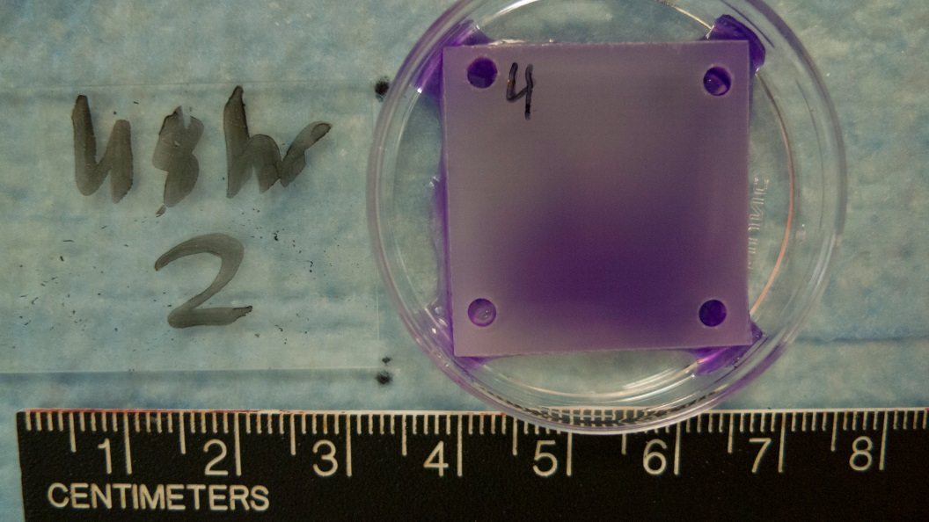  

OK! BAD! BAD!

Only select biofilm area Label, edges and holes Do not select the whole

were selected sample

1. Image of the control sample will appear and you will again be prompted to make a selection, as before.
2. You will be prompted to accept or reject the data. Look at the enhanced images to see if there was a selection error.
3. Data will be saved to the data file you chose or to an Excel file named “Biofilm Image Data.xls”, which will be located in the same directory as the images. Data stored includes the sample number, data and control file, BGI values for each color, and coordinates for your area selection.



1. A .tif image file with BGI enhanced images will be saved to the same directory with the name “[Biofilm image file]BGI.tif”
2. Repeat with subsequent files as desired

How to do batch processing

1. Open Matlab and BGIbatch.m in the command line
2. Select a folder
3. Choose a new or existing data file
4. Choose a control image for each file. In the example, this will be “000hr.jpg” in each case
5. Select biofilm region and control region for the first image.
6. Accept or reject the data
7. Select a control image for the second image file
8. Repeat steps 5-7 for every image file in the folder
9. Data will be save to an Excel file named “Biofilm Image Data.xls”